# 2016 Dodge Dynasty Champion – Matt Robson

Congratulations to Matt Robson for winning his second Dodge Dynasty League Championship! After sliding in as the #5 seed in one of the most competitive dynasty regular season finishes ever, Meat shocked us all by knocking off #4 Shannon, #1 Jeremiah, and #2 Joey in succession en route to the championship. Meat’s improbable title run was led by playoff MVP Aaron Rodgers, dependable running backs Lamar Miller and late round gem Jay Ajayi, and that’s pretty much it. After a strong showing against Shannon in the first round, Meat clashed with top dog and reigning defending champion Luck Dynasty, who led the league in scoring at over 102 points per game & notched over 200 more points than Meat during the year. But did Meat’s team wet the bed and wilt in the face of such an overwhelming uphill battle? Yes, it did. Fortunately for him though his opponent started an inactive Julio Jones and he narrowly survived. And in the marquee final matchup against Joey’s formidable but banged-up roster, featuring DeMarco Murray, Amari Cooper, and the greatest rookie running back in the history of running, only the Meatsian Dynasty answered the bell as he steamrolled his way to victory 96-60. Congrats Meat!

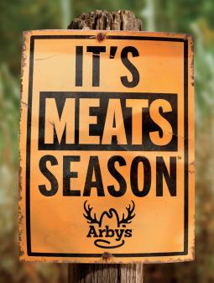

It sure is.

# 2016 Dodge Dynasty Awards

**Dodge Dynasty MVP**

Winner: David Johnson – Jeremiah

Runners-up: Ezekiel Elliott – Joe; Aaron Rodgers – Meat; Le’Veon Bell – Jay

**Playoff MVP**

Winner: Aaron Rodgers – Meat

Runner-up: Ezekiel Elliott – Joe

**Pickup of the Year**

Winner: Jordan Howard – Pohlmann

Runners-up: Davante Adams – Meat; Tyrell Williams – Joe; Tyreek Hill – Dave; Matt Ryan – George

**Sleeper of the Year**

(Playing for the team that drafted them)

Winner: Jay Ajayi – Meat

Runners-up: Spencer Ware – Pohlmann; Dak Prescott – Jay; Michael Thomas – George

**Bust of the Year**

(Non-Injury)

Winner: DeAndre Hopkins – Dave

Runners-up: Todd Gurley – Jen; Allen Robinson – Steve; Brandon Marshall – Meat; Cam Newton – Joey

**Rookie of the Year**

Winner: Ezekiel Elliott – Joe

Runners-up: Zeeeeeeeeeeeeke – Joe; EZ-E – Joe; [Hero in a Half Shirt](http://www.elevenwarriors.com/college-football/2016/05/70821/hero-in-a-half-shirt-the-history-of-ezekiel-elliotts-trademark-crop-top) – Joe

**Rookie of the Year, Non-Zeke Division**

Winner: Jordan Howard – Pohlmann

Runners-up: Michael Thomas – George; Tyreek Hill – Dave; Dak Prescott – Jay

**Comeback Player of the Year**

Winner: Le’Veon Bell – Jay

Runners-up: Jordy Nelson – Pohlmann; Mike Evans – Jeremiah; DeMarco Murray – Joe

**Dodge Dynasty Coach/GM of the Year**

Winner: Joe Hayek

Runners-up: Jeff Pohlmann; Matt Robson; Jeremiah Yugulis

**Emmitt Smith ‘Diamond Surrounded by Trash’ Award**

Great player on a terrible NFL offense

Winner: Todd Gurley – Jen

Runners-up: Terrelle Pryor – Dave; Carlos Hyde – Jen; Allen Robinson – Steve

**Fragile Freddie/Ailing Alshon Award**

Should-be great, but always hurt/rumored to be hurt

Winner: Rob Gronkowski – Dave;

Runners-up: Jordan Reed – Jay; Doug Martin – Meat; Jamaal Charles – Shannon

**Denver Broncos Willis McGahee Award**

Guy who many thought was washed up but wasn’t

Winner: Mike Wallace – Shannon

Runners-up: Frank Gore – Joe; Jimmy Graham – Dave; Larry Fitzgerald – Jay

**Cleveland Browns Willis McGahee Award**

Guy who many thought was washed up and was

Winner: Ryan Fitzpatrick

Runners-up: Justin Forsett, Victor Cruz

**Darko Milicic Regrettable Draft Pick Award**

Winner: Michael Floyd – Jay, via George (sorry Jay)

Runners-up: Jeremy Maclin – Jen; T.J. Yeldon – Pohlmann

**Dennis Quaid ‘Let’s Just Forget About My Brother’ Award**

Winner: Derek Carr

Runners-up: Aaron Rodgers; Joe Hayek

**Jay Cutler Face Award**

Best facial expression after back-breaking interception

Winner: Eli Manning

Runners-up: Philip Rivers; Blake Bortles

**Jim Harbaugh Bitterman Award**

Winner: Terry Bradshaw

**Ryan Lindley ‘How Is This Guy Starting an NFL Playoff Game’ Award**

Here’s what Ryan Lindley is [up to now](https://www.trulia.com/profile/ryan-lindley-agent-scottsdale-az-zgcph7xb/overview) (not a joke).

Winner: Matt McGloin – Raiders

Runners-up: Tom Savage – Texans; Matt Moore – Dolphins

**2016 Cleveland Browns In A Nutshell**

Winner: #GPODAWUND

Runners-up: This [fitting clip](https://twitter.com/MySportsUpdate/status/808018145789284352).

At least the Browns finally won a game. Merry Christmas ‘Cleveveland’ Browns!

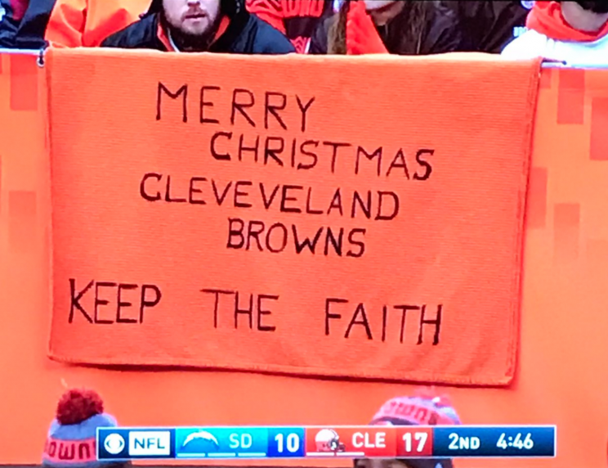

# Next Year’s Draft Order

Draft order for every round (excluding any 1st round comp picks)

1. Jen
2. Jay
3. George
4. Dave
5. Shannon
6. Pohlmann
7. Steve
8. Jeremiah
9. Joey
10. World Champion MEAT

# 2016 Adjusted Total Points (used for Non-Playoff Draft Order)

